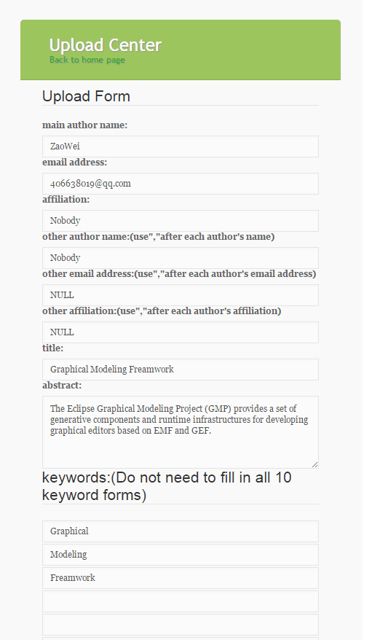When a user click Upload in the index, he will jump to the upload page(expect he has uploaded an article and this article is not be published).If the user already logged in, the main author name and email address will be filled in automatically. The user should fill in all forms(except keywords) and choose a pdf file to upload. Only .pdf file can be uploaded. If he input same author name, article title, or wrong email address format, he cannot upload the article. After submitting, if he is not an existing author, he will receive an email and get his username and password from it.

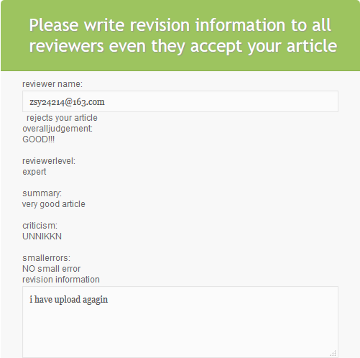

After 3 reviewer reviewing author’s article, and after 7 days, author can receive reviewer’s feedback and whether he accepts your article. If all reviewer accept the article, it can be published. Or if one reviewer rejects the article twice, it can not be published. Author should upload a revised article and write revision information to reviewer.

Challenges

For author part, there are several challenges we have met.

1. The first problem I met is that the upload path is different between our own computer and the school tomcat server. We cannot find the upload path directly from the address of the folder. Finally, we asked our classmates and find the upload path that we can use to store our uploaded files.
2. The second problem appeared after dealing with the first problem. It is that we cannot access the student tomcat tomtemp store space by using our own computer, so it is difficult for us to try our upload and download function after leaving the lab. We did not find a good way to deal with this problem.
3. The third problem is sometimes the school student tomcat server do not use of latest code. After changing .class file in the tomcat server, it also use the old one, so we cannot see how we system work immediately. To see whether it is updated, we try to output some unique words on the web page to see the version. And sometimes, by modifying the web.xml file(delete and undo), is can update immediately.